025 Gulp - concat

Gulp Kata List – Blog Page

[Gulp Kata List on GitHub](https://github.com/robertdunaway/katas-gulp)

# Duration

5 minutes

# Brief

In this kata we will combine multiple files into one.

### For More Information

BING/GOOGLE: “Gulp concat minify javascript”

Book: <http://www.amazon.com/Gulp-Quick-guide-getting-running/dp/151468960X>

# Instructions

Get tutorial folder or the entire katas-angular2 repo.

Open the [before/*.sln] file and execute the kata.

Feel free to execute this kata multiple times because repetition creates motor memory.

# Github

* Before (start kata with this)
  + https://github.com/robertdunaway/katas-gulp/tree/master/025%20Gulp%20-%20concat/before
* After
  + https://github.com/robertdunaway/katas-gulp/tree/master/025%20Gulp%20-%20concat/after

# Kata

Bundle all the JavaScript files, in src, and output them into a single file named all.js. Then minify the all.js file and output all.min.js.

# Review

Install the NPM modules needed.

npm install gulp-concat --save-dev

npm install gulp-uglify --save-dev

Add the references to the gulp file.

, concat = require('gulp-concat')

, uglify = require('gulp-uglify')

Create a task to concatenate, minify, and map all JavaScript files in the src/js folder.

gulp.task('concatJS', function () {

return gulp.src('src/js/**/*')

.pipe(concat('all.js'))

.pipe(sourcemaps.init())

.pipe(uglify())

.pipe(rename({

extname: '.min.js'

}))

.pipe(sourcemaps.write('./'))

.pipe(gulp.dest('./wwwroot/js/'));

});

gulp.task('default', function () {

runSequence('copy-to-wwwroot', 'concatJS');

});

Just seems like a good place to insert an image.

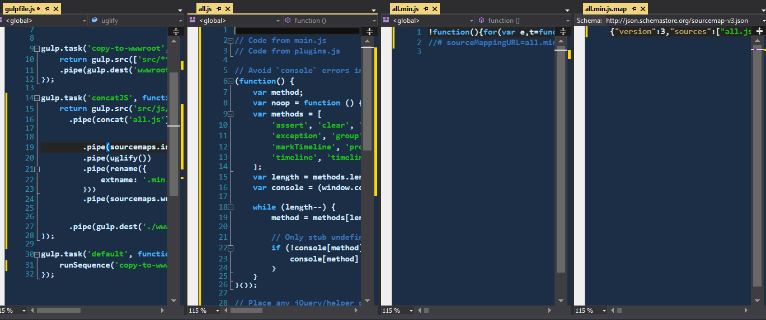

# Next

Take a few minutes and imagine more examples.